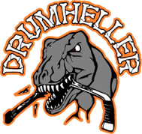
Drumheller Minor Hockey Association
Executive Board Meeting Request Form

Please fill out the form below if you are interested in attending a DMHA board meeting.

Your request will be reviewed, and you will receive a phone call or email back from a board member of the executive regarding your request.

- Who would like to request a meeting with the DMHA board of executives?

First Name | Last Name
Email Address | Telephone Number

- Reason for the meeting request?
__________________________________________________________________________________________________________________________________________________________________________________________________________________________________________________________________________________________________________________________________________________

- What are you looking to see for an outcome with meeting with the DMHA board?
___________________________________________________________________________________________________________________________________________________________________________________________________________________________________________________________________________________________________________________________________________________________________________________________________________________________________________________________________________________________________________________________________________________________________________________________________________________

